Garden Creek School
English
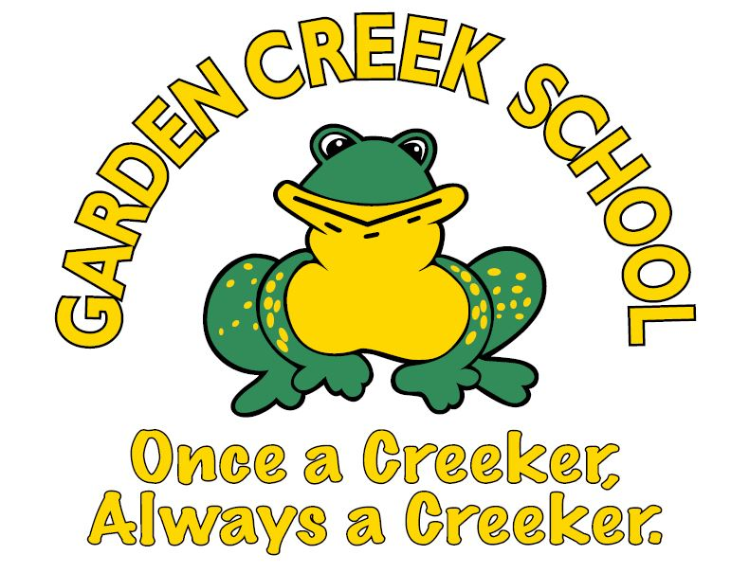
Grade 4 English Program
Supply List

2023-2024

- Bookbag
- Lunchbox or bag
- Pair of Sneakers (to be worn indoors and for gym class)
- Headphones/earbuds (preferably not wireless, do not need to be new)
- USB/Flash Drive (do not need to be new)
- Boxes of Kleenex (2)
- A box of band aids
- Water bottle to be kept at school
- Reusable fork and spoon to be kept at school
- Ziplock Bags (1 box Small and 1 box Large)

Please make sure you send your child with a reusable spoon or fork when they need one, as we will not be providing single-use disposable cutlery day to day.
Due to rising cost of supplies, we have increased our student fees by $5. Consumable supplies this year will be $65, including school agenda. A portion of school supply money may be used for special projects and other educational expense.
Please make payments through School Cash Online starting September 5th, 2023, at:
https://district.schoolcashonline.com/
on or before Friday, September 29th, 2023 at 3:00 pm
Consumable supplies will be purchased by the school for your child’s class. They will be provided to each child as necessary throughout the school year. This allows us to purchase high quality supplies at a cheaper rate than charged to individuals. It also ensures that all children have the appropriate supplies when they need them.

