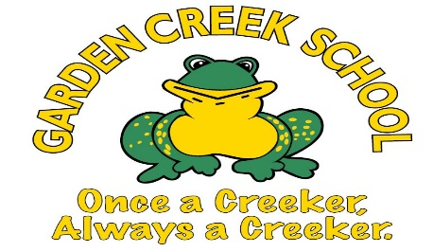**Garden Creek School**



**English**

**Grade 1-English Program**

**Supply List**

**2025-2026**

* 1 Box of Large Zip-lock Bags
* Indoor Sneakers (Velcro or “slip on” - No laces, please)
  + Please initial/label on the inside sole or tongue to make identification easier
* Extra set of clothes – socks, t-shirt, pants and underwear (in a Zip-lock bag with your child’s name on the outside)
* Book bag (large)
* Lunchbox or lunch bag
* A labelled re-useable water bottle to be left at school
* 1 Box of sandwich Ziploc bags
* 2 Boxes of Kleenex
* 1 Box of Band Aids

Consumable supplies this year will be $60. A portion of school supply money may be used for special projects and other educational expense.

**Please make payments through School Cash Online starting September 2nd, 2025, at:**

[**https://district.schoolcashonline.com/**](https://district.schoolcashonline.com/)

**on or before Tuesday, September 30th, 2025, at 4:00 pm**

Consumable supplies will be purchased by the school for your child’s class. They will be provided to each child as necessary throughout the school year. This allows us to purchase high quality supplies at a cheaper rate than charged to individuals. It also ensures that all children have the appropriate supplies when they need them.